#### Ideation Phase

#### Brainstorm & Idea Prioritization Template

|  |  |
| --- | --- |
| **Date** | 27 October 2022 |
| **Team ID** | PNT2022TMID29155 |
| **Project Name** | Project- Signs with smart connectivity for better road safety |
| **Maximum Marks** | 4 marks |

#### Step-1: Team Gathering ,Collaboration and select the problem statement

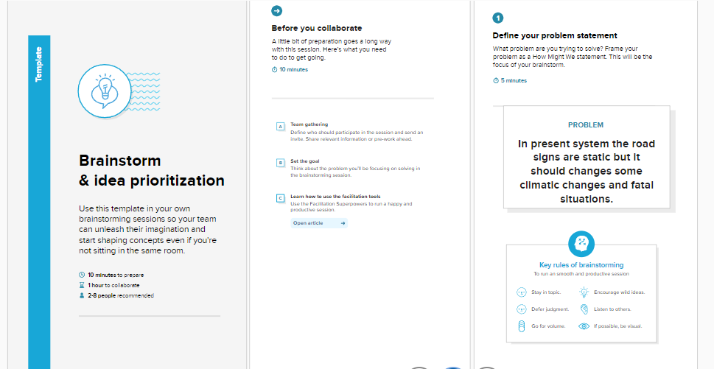

#### Step-2: Brainstorm ,Idea Listening and Gathering

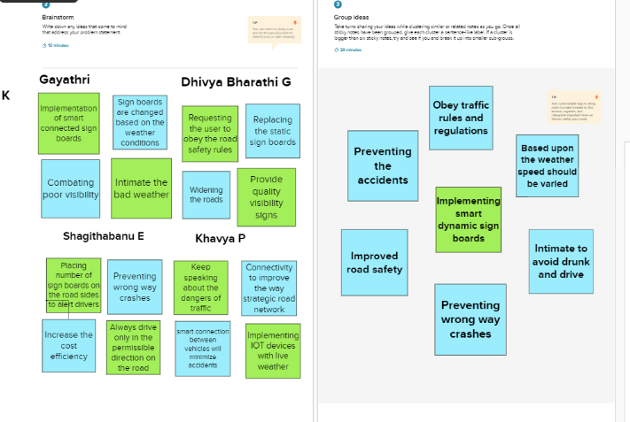

#### Step-3: Idea Prioritization

